**Task Actions:** ( to be completed by programmer )

|  |  |  |
| --- | --- | --- |
| Project Settings: <https://drive.google.com/open?id=1bIWSzxDlhNRyUOUX_9wq728ZlzKtD0T2mv1hEl6MYnA> | | |
| Add changes to test site: **YES** | Alter database on test site: **YES** | Update SVN: **YES** |
| Add changes to live site: **NO** | Alter database on live site: **NO** | Update Ticket:**NO** |
| Create SQL to alter database: **NO** Note: if creating a sql script file please use the same name as this doc eg. {task}.sql | | |

**Task Process**: ( to be completed by Project Manager )

|  |  |
| --- | --- |
| Test task in test site: **~~YES / NO~~ / Not Tested** | Test site check passed: **YES / NO / Not Tested** |
| Test task in live site: **N/A** | Live site check passed: **N/A** |
| Client Notification Required: **NO** | Client Notified: **NO** |
| Project Cost Sheet Updated: **~~YES~~ / NO** | Db Changes Applied: [ Test Site: **YES / NO** | Live Site: **YES / NO** ] |

1. **Task Requirement / Description**
2. **UI Flow**
3. **Programming Logic**
4. **Database**

**1. Task Requirement / Description**

A) Catalog

Please add a downloadable catalog to the new clip2 version of the Merriman website. the catalog should have a front page with a logo, a first page with list of the categories in the the same order as the website categories in the menu.

After the first page then show all products from the website on a separate page with the category and product name in the page heading, then product image and product details in the catalog body.

If user clicked on the top link in the top main menu then email to customer a link to show all products in catalogue  
If user clicked on the link in the category page then send email to the cusotmer to show all products in the category only.   
If user clicked on the link on the product detail then straight away show pdf for the product only ( no front page or category page )

<see image on next page>

This is a photo taken from a paper catalog for Merriman. Please make product pages similar to the image. For product table use same table as the website.

When customer clicks on a link to download the catalogue please show a modal window with:

B) Register to download  
When a customer tries to download the catalog show a modal with title “Registration Required”  
in modal show fields First Name, Last Name, Email, Confirm Email. And for button “Email Catalogue”  
When customer click on email catalogue save users details to a new database table “contacts” and email a link to the customer to download the catalogue.

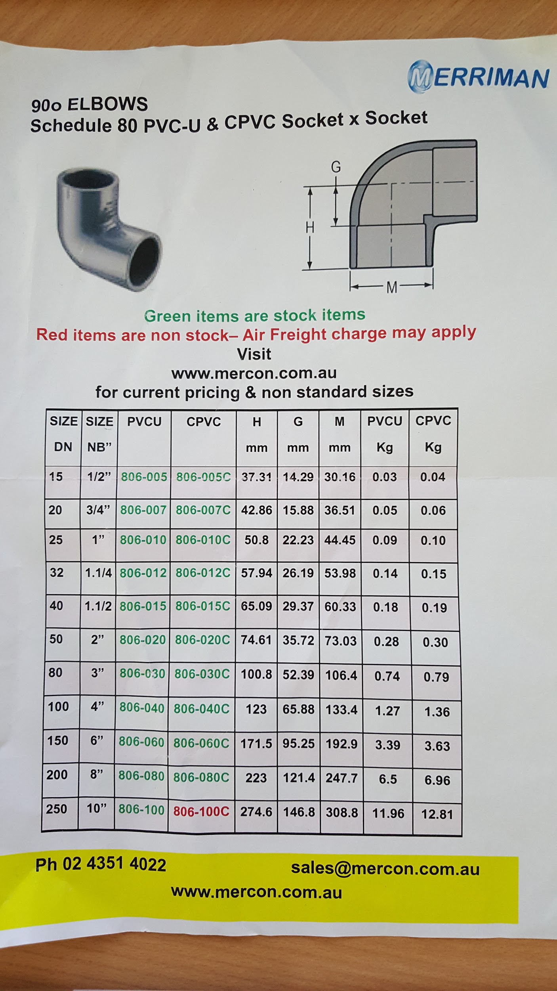

**2. UI Flow**

Use link on top of menu page to show modal to email the catalogue. Change the link name to “Email Product Catalogue”. This link will be visible to users on all pages.

Add a link to the top of the category page called “Email {category name} as a Catalogue”

Add a link to the next to each product called “Email Product Sheet”

**3. Programming Logic**

1. Save user details in modal to db
2. create url string to use in email body  
   make sure link is temporary ( add encrypted datetime in string )  
   add categoryid if user click category link  
   add productid if user click product link  
   from email: [sales@merrimancontrols.com](mailto:sales@merrimancontrols.com)  
   subject: Merriman Controls Product Catalogue  
   body: email link url only
3. Send email to user
4. When user clicks on link
   1. check datetime in url is not more then 24hrs old
      1. if older then 24hrs show error message “This link has expired”  
         abort further processing
   2. check if filtering of products by category or product id
   3. if filter by product id then skip to point g
   4. generate front page of pdf
   5. generate first page of pdf + loop categories and show cat list
   6. generate one product page for each product
5. User download’s pdf

**4. Database**

Add new table:

* Contacts  
    
  contactID - bigint primary autoincreament  
  firstName - varchar(255) required  
  lastName - varchar(255) required  
  email - varchar(255) required email only  
  sendEmail - bit required default = true

END